1.Student Performance Analysis (4×4 Matrix) Program:-
import numpy as np
# 4x4 marks matrix: rows = students, columns = subjects # Columns: [Math, Science, English, History] student_scores = np.array([
[85, 90, 78, 88],
[92, 80, 85, 90],
[75, 88, 82, 84],
[89, 76, 91, 87]
])
subject_names = np.array(["Math", "Science", "English", "History"])
# Average score for each subject (column-wise mean) subject_avgs = student_scores.mean(axis=0)
# Subject with highest average max_index = subject_avgs.argmax() highest_subject = subject_names[max_index] print("Average score for each subject:") for name, avg in zip(subject_names, subject_avgs):
print(f"{name}: {avg:.2f}") print("Subject with highest average score:", highest_subject)

Output:-
Average score for each subject:
Math: 85.25
Science: 83.50
English: 84.00
History: 87.25
Subject with highest average score: History 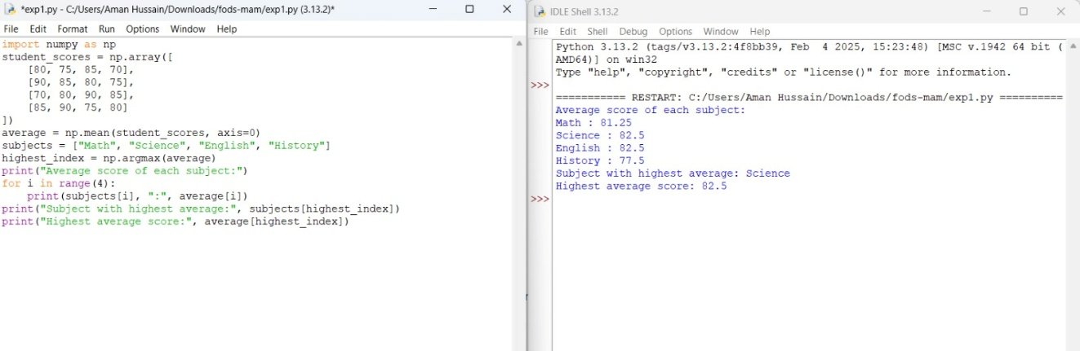

2.Sales Data Analysis (3×3 Matrix) Program:-
import numpy as np
# 3x3 matrix: rows = products, columns = individual sale prices sales_data = np.array([ [200, 250, 220],
[150, 180, 160],
[300, 310, 290]
])
# Average price of all products sold average_price = sales_data.mean() print(f"Average price of all products sold in the past month: {average_price:.2f}")
Output:-
Average price of all products sold in the past month: 228.89
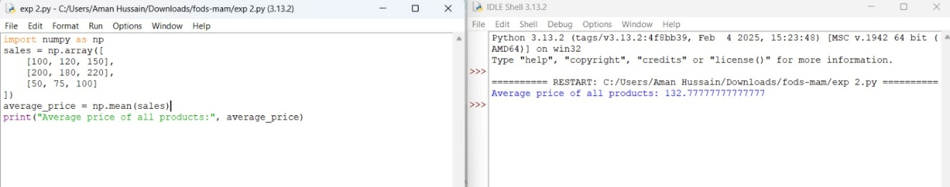

Housing Data (CSV Imported into NumPy) Program:-
import numpy as np
# Columns: [bedrooms, square_footage, sale_price] house_data = np.array([ [3, 1200, 200000],
[5, 1800, 300000],
[4, 1500, 250000],
[6, 2000, 350000],
[5, 1700, 320000]
])
# Filter houses with more than 4 bedrooms mask = house_data[:, 0] > 4 filtered_houses = house_data[mask]
# Extract sale prices from filtered houses (column index 2) sale_prices = filtered_houses[:, 2]
# Average sale price of houses with more than 4 bedrooms average_sale_price = sale_prices.mean() print("Houses with more than 4 bedrooms:") print(filtered_houses) print(f"\nAverage sale price (more than 4 bedrooms): {average_sale_price:.2f}")

Output:-
Houses with more than 4 bedrooms:
[[ 5 1800 300000]
[ 6 2000 350000]
[ 5 1700 320000]]
Average sale price (more than 4 bedrooms): 323333.33
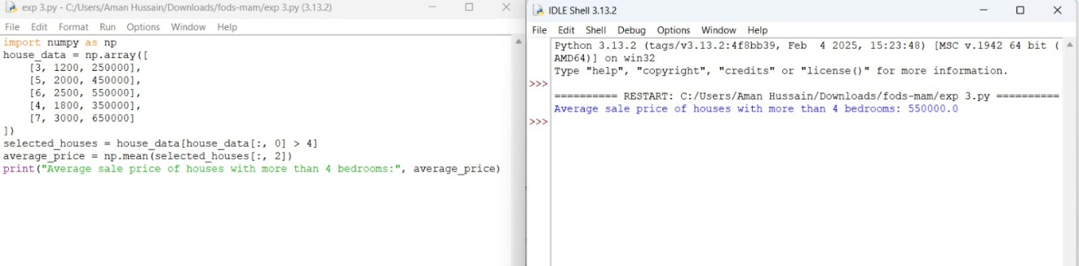

Quarterly Sales Performance Program:-
import numpy as np
# Quarterly sales data: [Q1, Q2, Q3, Q4] sales_data = np.array([150000, 175000, 190000, 210000])
# Total sales for the year total_sales = sales_data.sum() # Percentage increase from Q1 to Q4 q1 = sales_data[0] q4 = sales_data[3] percentage_increase = ((q4 - q1) / q1) * 100 print(f"Total sales for the year: {total_sales}") print(f"Percentage increase from Q1 to Q4: {percentage_increase:.2f}%")

Output:-
Total sales for the year: 725000
Percentage increase from Q1 to Q4: 40.00%
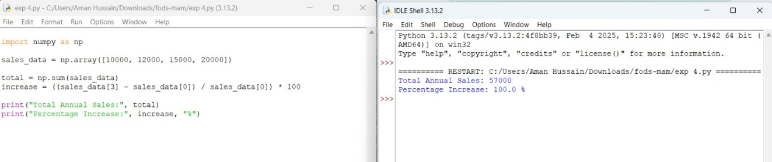

Fuel Efficiency Analysis Program:-
import numpy as np
# Fuel efficiency of car models in miles per gallon (mpg) fuel_efficiency = np.array([18.5, 20.0, 22.5, 25.0])
# Average fuel efficiency average_efficiency = fuel_efficiency.mean() # Compare model 0 and model 3 model1_index = 0 model2_index = 3 eff_model1 = fuel_efficiency[model1_index] eff_model2 = fuel_efficiency[model2_index] # Percentage improvement in fuel efficiency percentage_improvement = ((eff_model2 - eff_model1) / eff_model1) * 100 print(f"Average fuel efficiency: {average_efficiency:.2f} mpg") print(f"Fuel efficiency of Model {model1_index}: {eff_model1} mpg") print(f"Fuel efficiency of Model {model2_index}: {eff_model2} mpg")
print(f"Percentage improvement from Model {model1_index} to Model {model2_index}: {percentage_improvement:.2f}%")

Output:-
Average fuel efficiency: 21.50 mpg
Fuel efficiency of Model 0: 18.5 mpg
Fuel efficiency of Model 3: 25.0 mpg
Percentage improvement from Model 0 to Model 3: 35.14%
